**“Project Plan and Third Increment”**

**“Spring 2017”**

# “Submitted by **Team 13”**

Onica Sai Prasanna Lakshmi, Rayineedi– 80

Venkata Krishna, Podili– 72

Mamatha Yadav, Chekuti– 11

Sreelekha Reddy, Kommareddy– 45

## “1. Introduction”

### “World Explorer”

When people keep travelling to different places, there is always a limitation of information about the place they are travelling to. Therefore, this encouraged us for a travel guide mobile application as smartphones are evolving exponentially and becoming popular to offer greater services to multiple users using GPS navigation, web navigation etc. The tourists will be able to explore many new tourists’ places just by viewing the updated information in the application. This will also enable easy travel planning by knowing the sales prices and developments happening all around due to the increase in the usage of the mobile equipment’s.

## “2. Project Goal and Objectives(revised)”

### “2.1 Overall Goal:”

The Main Objective of this Application is to create a user-friendly Android based Application which enables users to know about places and areas instantly that they are not familiar with and provide them with the reviews of past and an ability to share their experiences.

### “2.2 Specific Objectives (Problem Statement):”

* Depending on the User Location, Tourist Attractions in a place can be displayed
* Entire information such as distance from current location, history, significance, images, and reviews etc. of a place can be viewed
* Associated with various applications which allows to view and book different amenities which are necessary to accomplish the trip
* User can view and record the reviews about the visited place

### “2.3 Specific features:”

2.3.1ThisApplication enables the user to retrieve the information such as places to visit, Food & restaurant availability, Events occurring, Transport facility available in that place.

2.3.2 After Tourist Attractions got displayed, the user can select a place from the list of attractions after which entire details such as location, contact information, and address along with select date and time attributes will get displayed

2.3.3 This is associated with My Schedule which allows to view his upcoming or current schedules

2.3.4 The user can view and record the reviews about the visited place

### “2.4 Significance:”

* The information in the application can be shared among tourists instantly and analyzed by the shared ones.
* The main disadvantage of insufficient information of the resources, untapped opportunities for tourism companies and the enhancement of the travel experience is overcome by providing meaningful insight for the trips.
* It provides connectivity to many smart applications for travelers.
* It provides Google’s information and resource source for marketers.

## “3. Project Plan”

### “1. Zen-Hub Screenshots:”

In this third increment we created four Milestones that is., for Increment-1, Increment-2, Increment-3, Increment-4. Under Increment-2 we have issues regarding Zen-Hub, User Stories and test Cases, Schedule, Updating UI, Updating UI, Modifying UML diagrams

#### “Mile-Stones Created:”

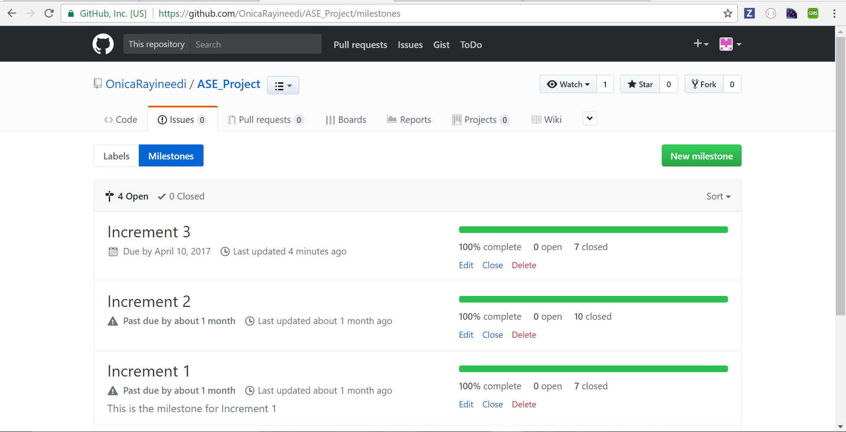

### “2. Project Timeline, Members, and Task Responsibility:”

For this Increment, there are seven issues created and below screenshots describe how tasks been assigned to the team members

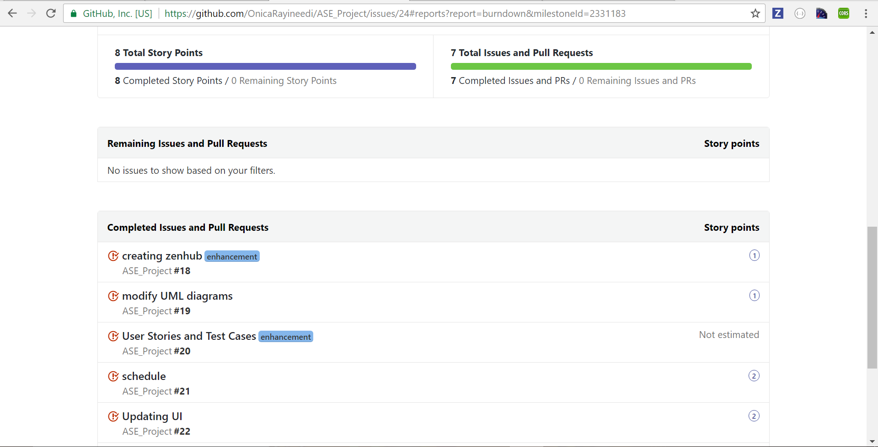

### “3. Burn-Down chart:”

This Burn-Down chart is generated for Increment-3 which the above designed issues created

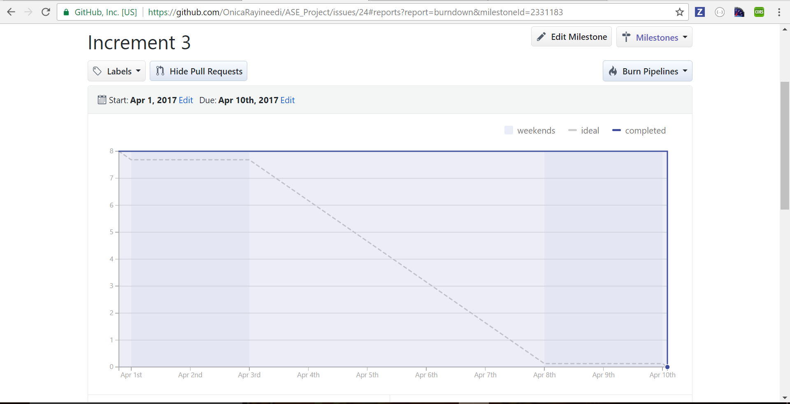



## “4. Third Increment Report”

### “4.1 Existing Services/REST API:”

* Facebook API
* Foursquare API
* M-Lab
* Google-Maps

### “4.2 Detail Design of Features:” “4.2.1. Wireframes:”

* **“Login Page:”** A Login Page is created with Email ID and Password as attributes.

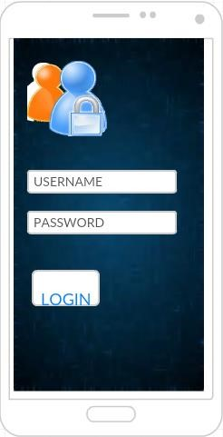

* **“Registration Page:”** A Registration Page is created with First Name, Last Name, Password, username

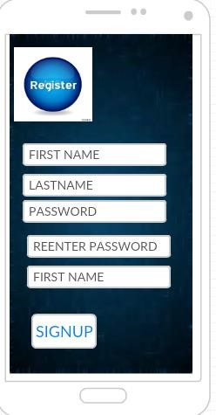

### HOME SCREEN

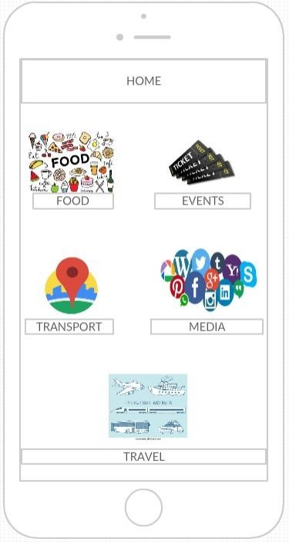

### 4.2.2 Class Diagram:”

This diagram depicts the static structure of the Application using Classes and their Attributes.

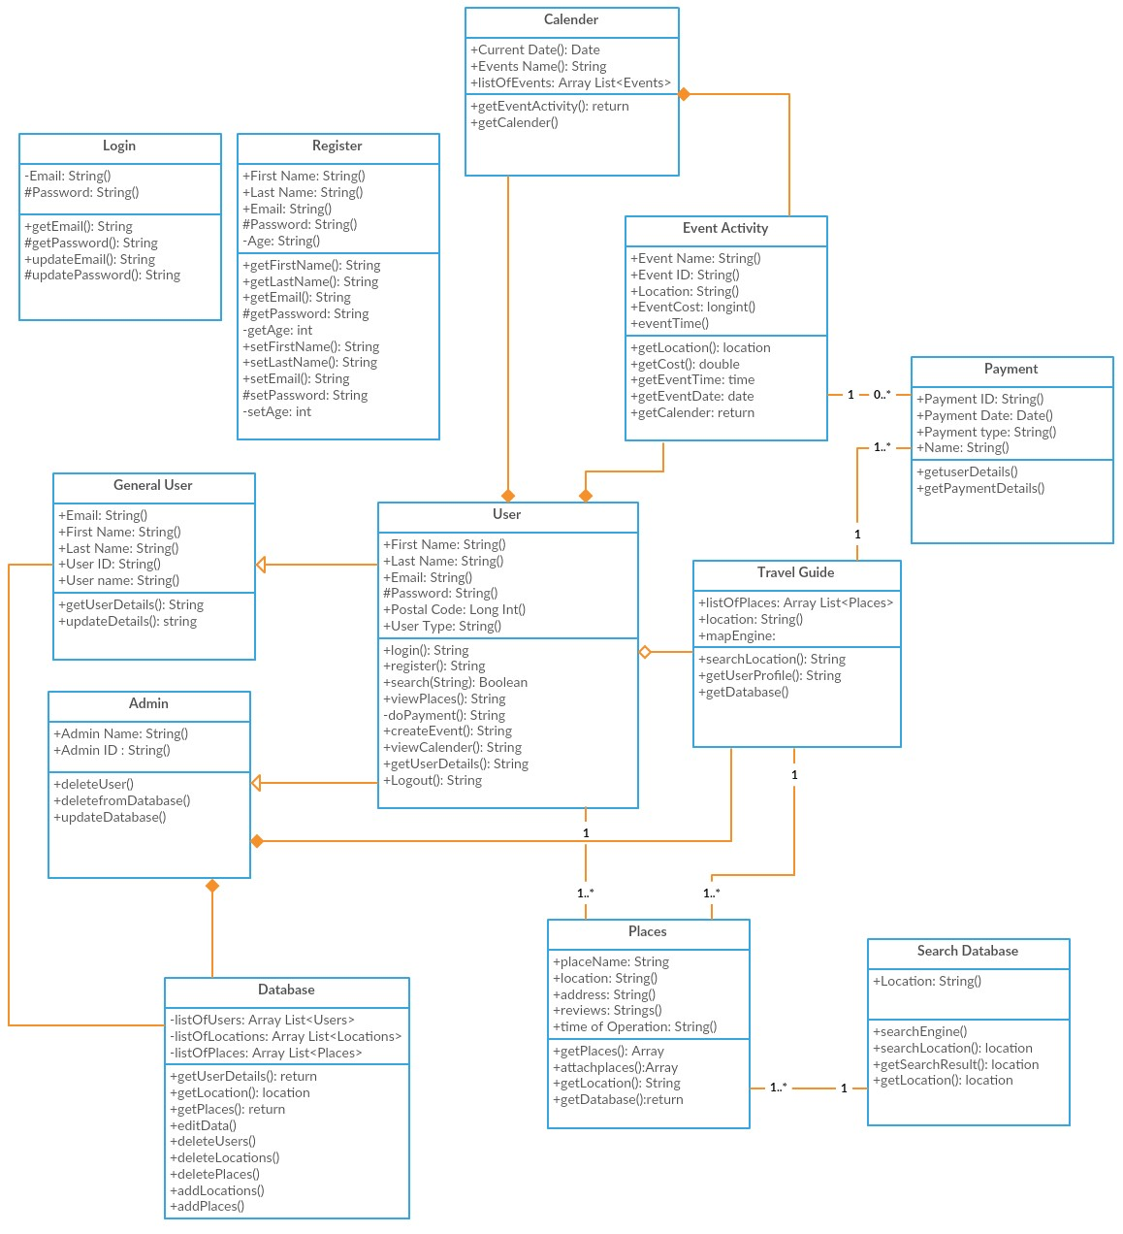

### 4.2.3 Sequence Diagram:”

This Sequence Diagram depicts the interaction mechanism of the objects implemented in the system application.

#### “Sequence Diagram for Login and registration:”

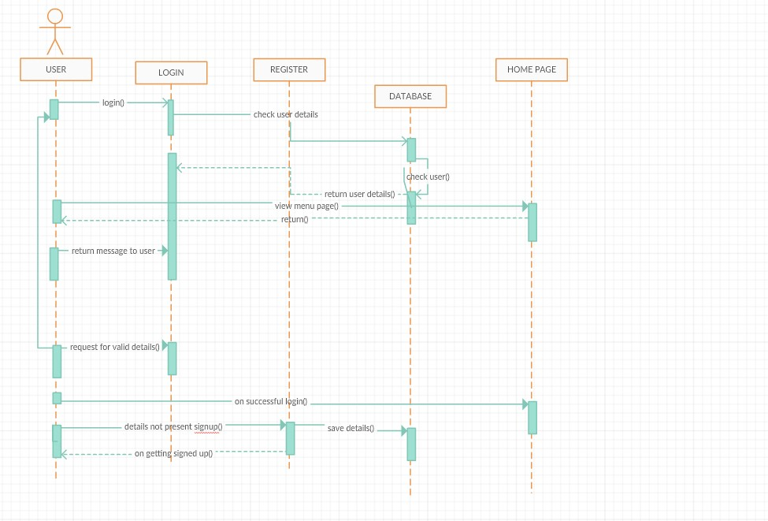

#### “Sequence Diagram for Home Page:”

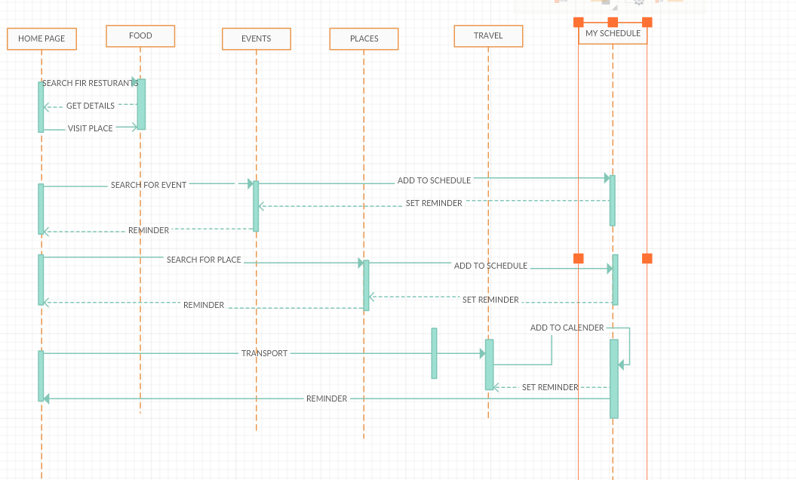

**“4.2.4 Architecture Diagram:”**

Structure and Behavior of the application is described in the system architecture.

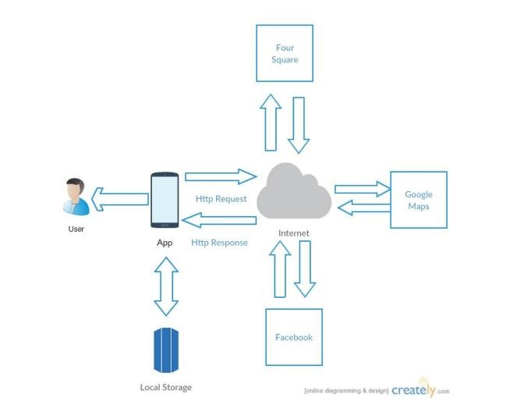

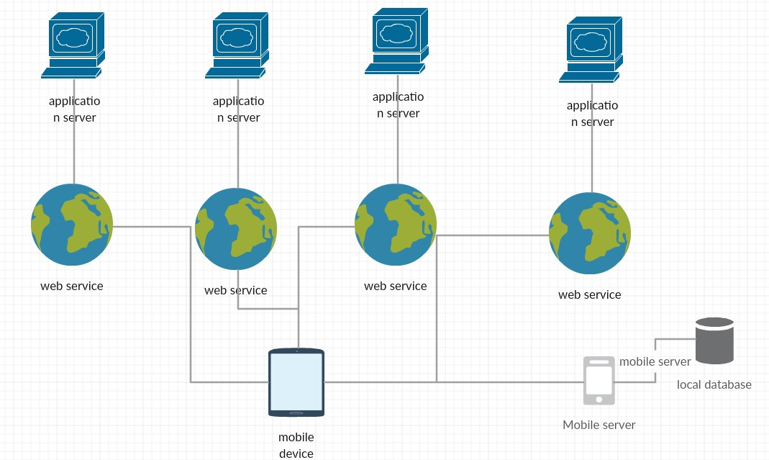

### “4.2.5 Use Case Diagram:”

Use case diagram represents the interaction of user with the application

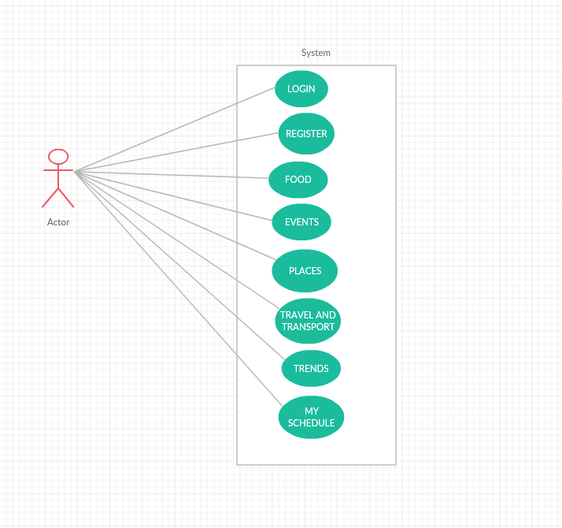

### “4.2.6 User Stories:”

|  |  |  |
| --- | --- | --- |
| As a | I want to | So, that |
| User | Search for the tourist places and events based on my location | I can visit that place as a tourist |
| Get the various Tourist Attractions located in that location | I can visit all the Tourist Attractions located in that place |
| Get Directions and navigation to the Tourist place selected | I do not have any problem in finding the location of the selected place |
| Get all the information such as contact number, Locations, images, video’s (if present) and reviews | I can gain more knowledge about that place |
| Get all the details about Basic Amenities present in that place | I do not face any problem by visiting that place |
| To schedule events and update calendar | I can view the dates and events planned on that days (such as visiting a place) |
| to place the reviews of visited place | I can give suggestions to future visitors |

### “4.2.7 Unit Testing:”

|  |  |  |  |
| --- | --- | --- | --- |
| Case | Test Case Description | Expected Result | Actual Result |
| Events Search | On searching the location | Display the nearby events | PASS |
| Places Search | On searching the Location | Display the nearby visiting spots | PASS |
| Get Directions | On clicking on a location | Display G-Maps linked with the location along with the address and Contact Info | PASS |
| Travel & Transport | On searching the Location | Display places to live and transportation facilities | PASS |
| Food | On searching the Location | Display nearby restaurants | PASS |

**“5. Implementation and deployment:”**

Android Application which we developed till date has been designed using android studio and result is observed using emulator and in an android mobile.

### “Screen Shots:”

* By opening the Application in the android mobile following login page will be displayed which has email and password as attributes.
* If the user enters Invalid credentials, then an alert appears stating that Password do not match or Invalid Email
* If the user is new to the application, then he can register by using the registration page
* On clicking on the registration button a registration form appears
* New user should fill all the details and then by clicking on register button and get migrated to login page
* After successful registration, an alert appears with a message Success
* Then you will be navigated to the home page
* In the home page, you can find food, events, travel and transport, places, and trends icons
* By clicking on the respective icons, you can find the results accordingly
* By clicking on each results, Address and Location of the respective result will get displayed along with the G-map also choose date and time attributes are also present where the user can choose date and time to schedule his event
* Events scheduled can be viewed by clicking on My Schedule Icon
* These Events are stored in M-Lab and can be retrieved when the user clicks My Schedule Icon
* A delete button is present in extreme right which enables the user to delete the event if necessary

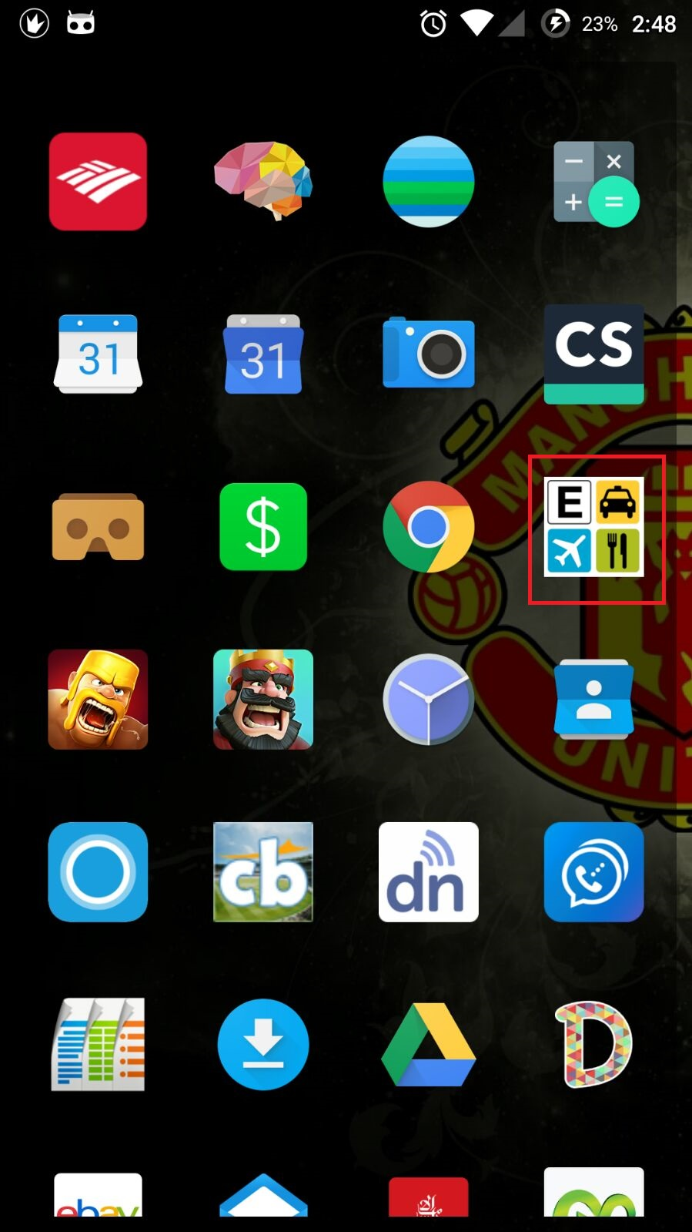

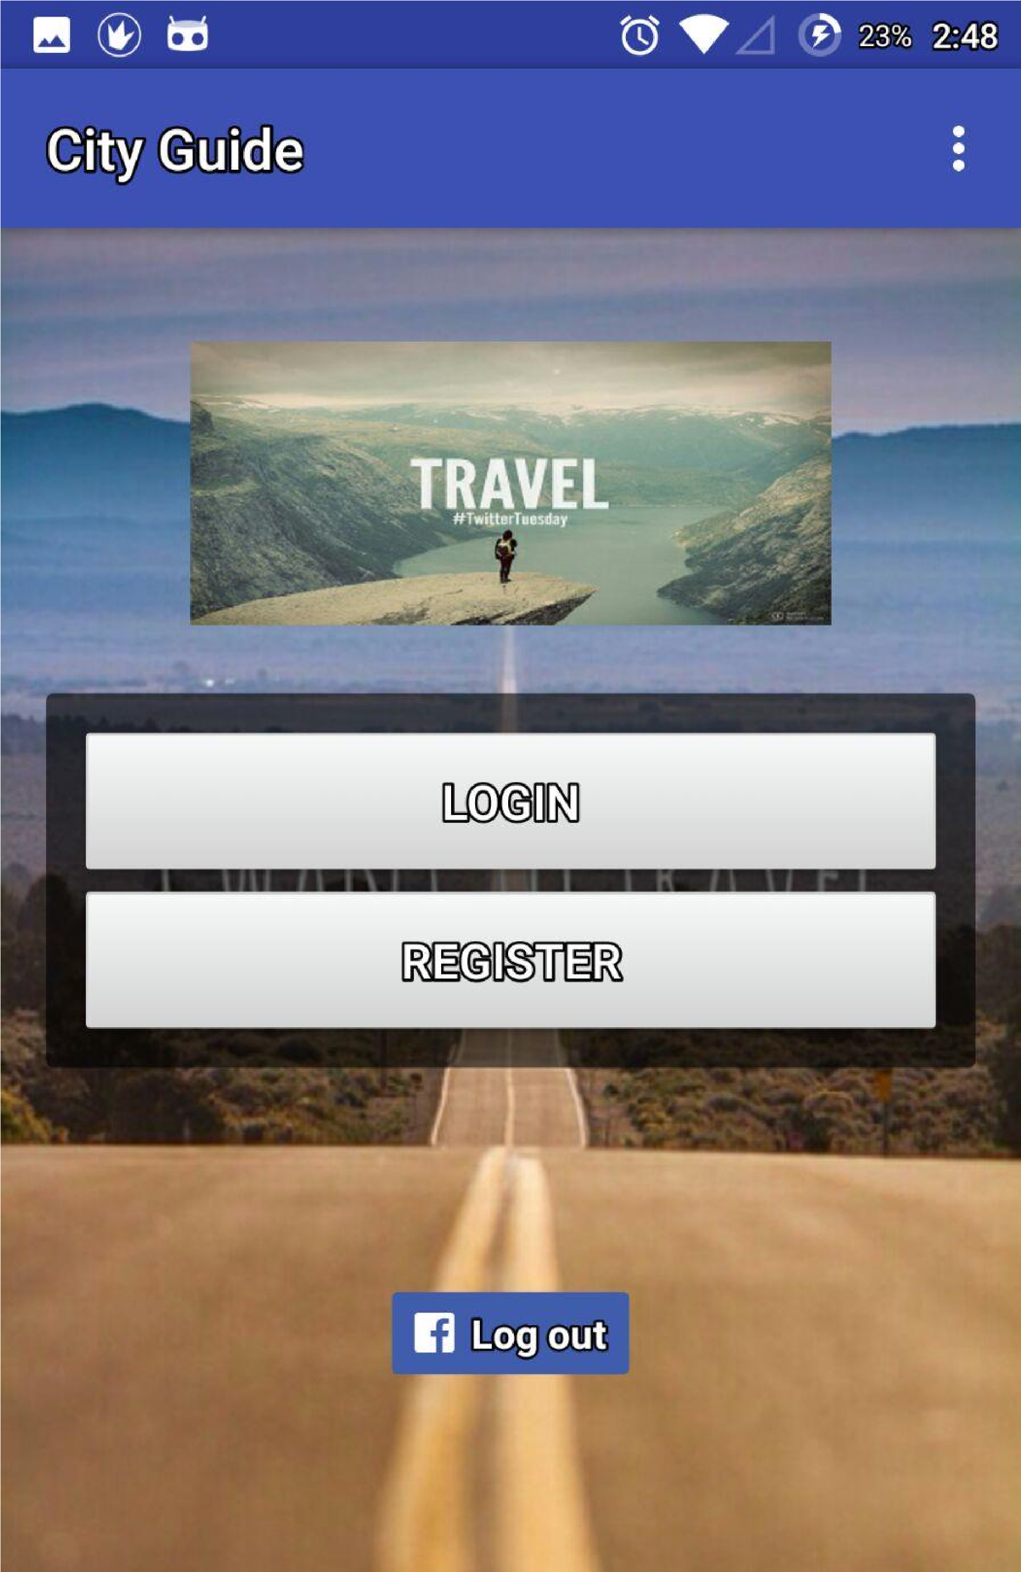

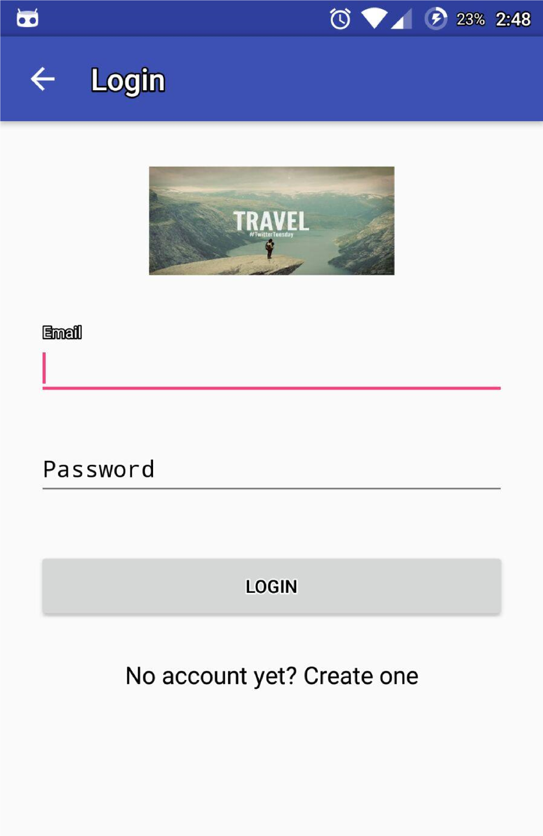

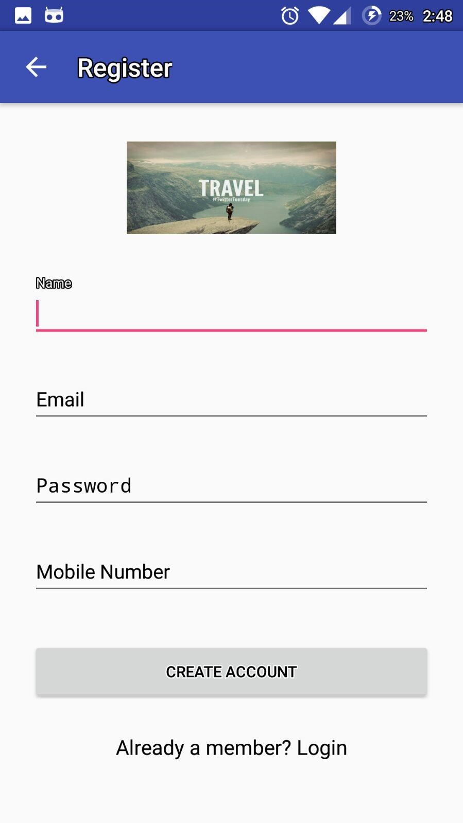

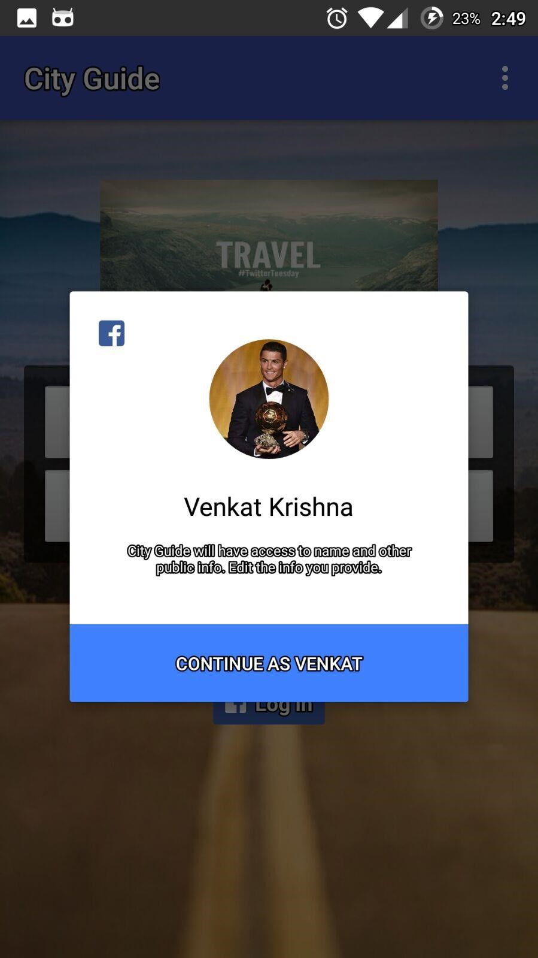

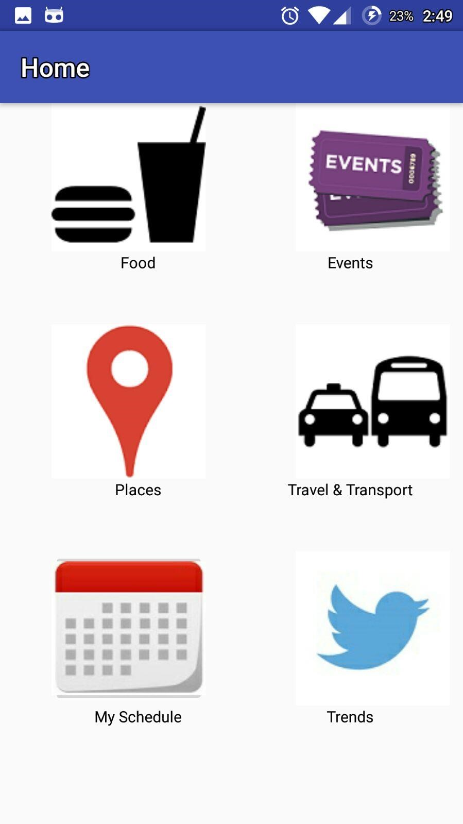

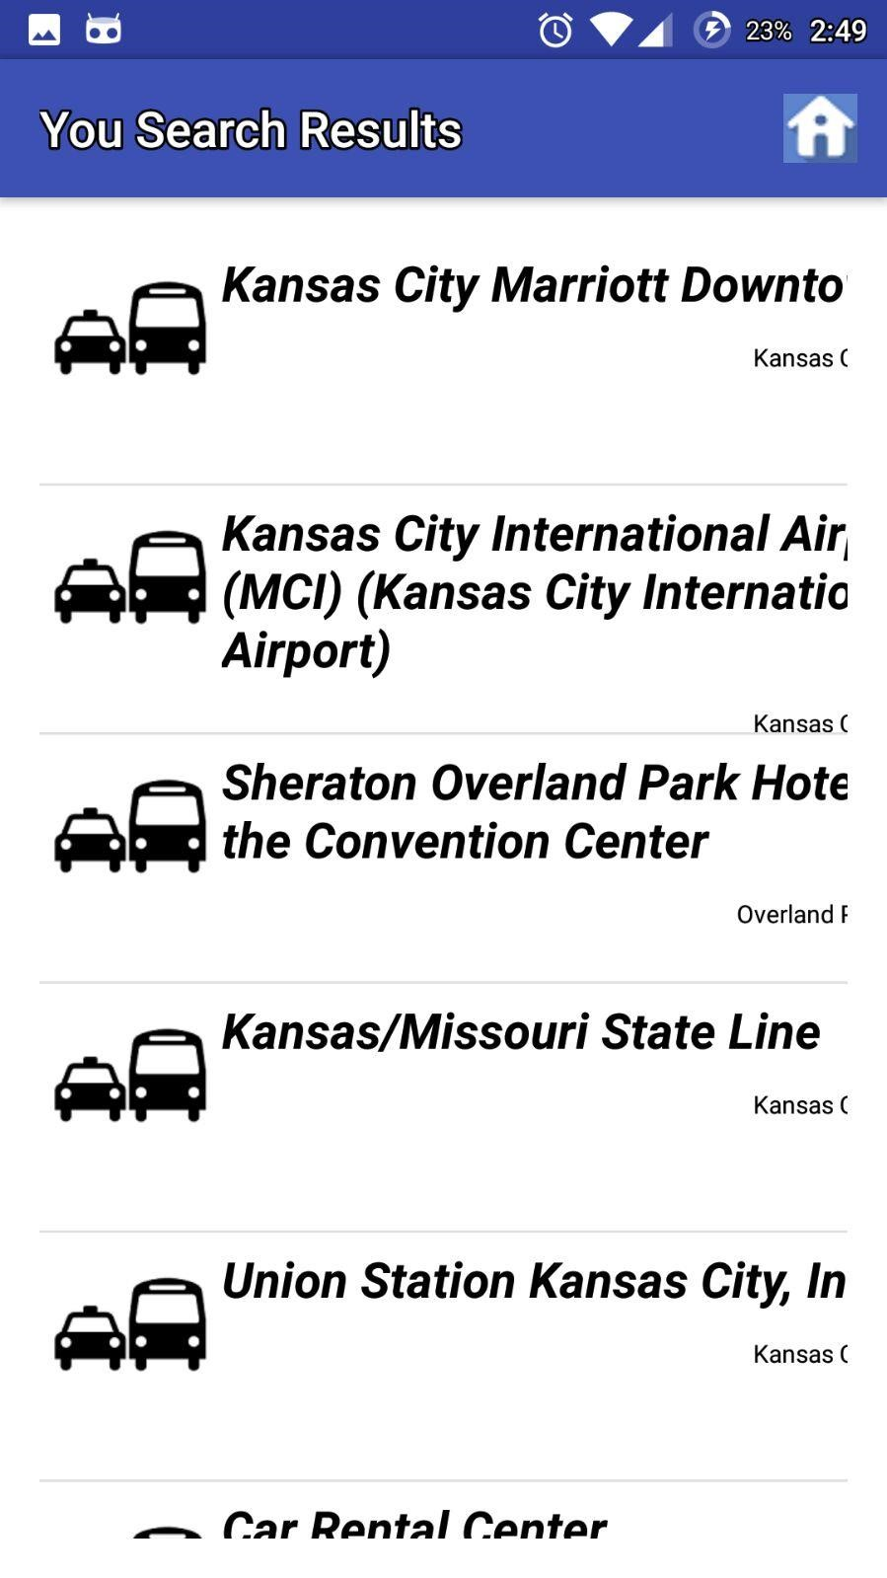

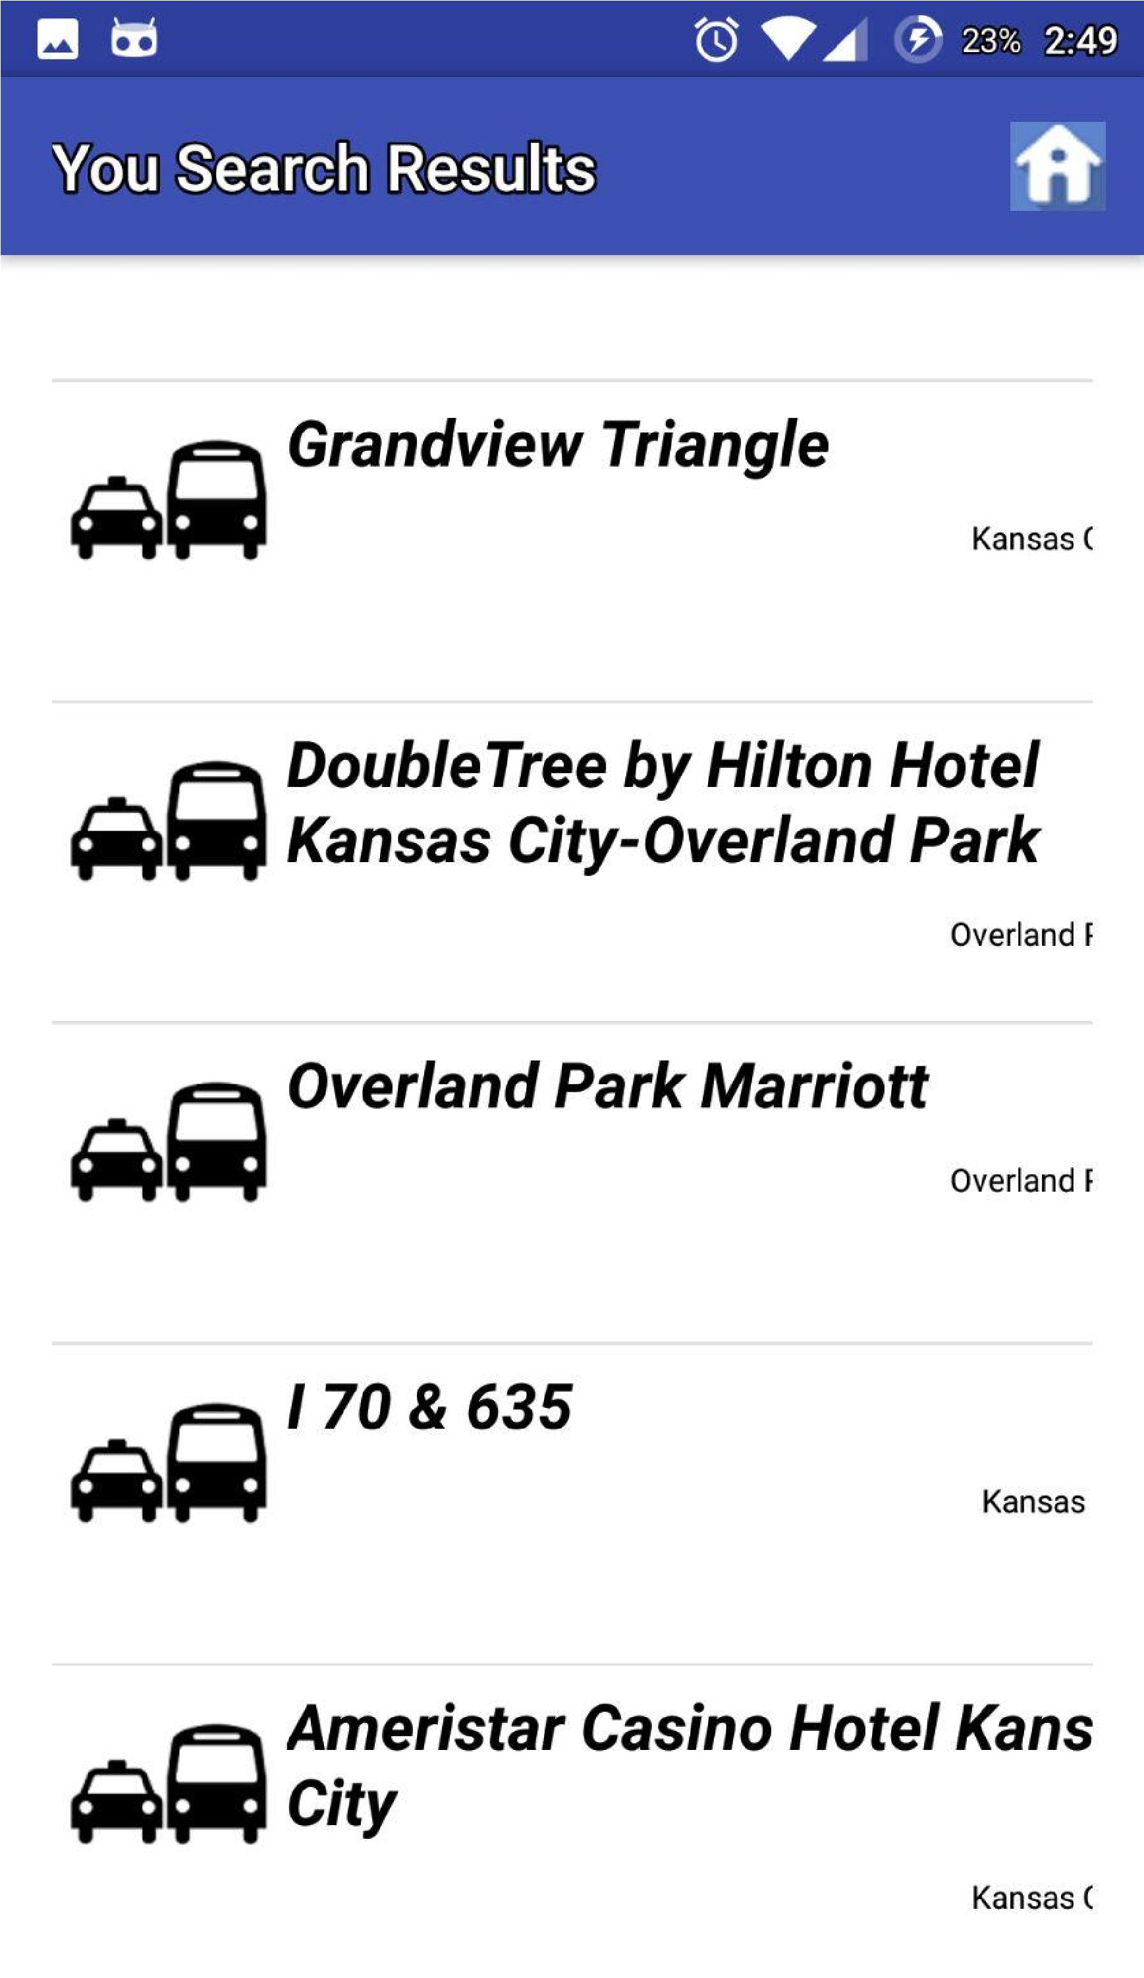

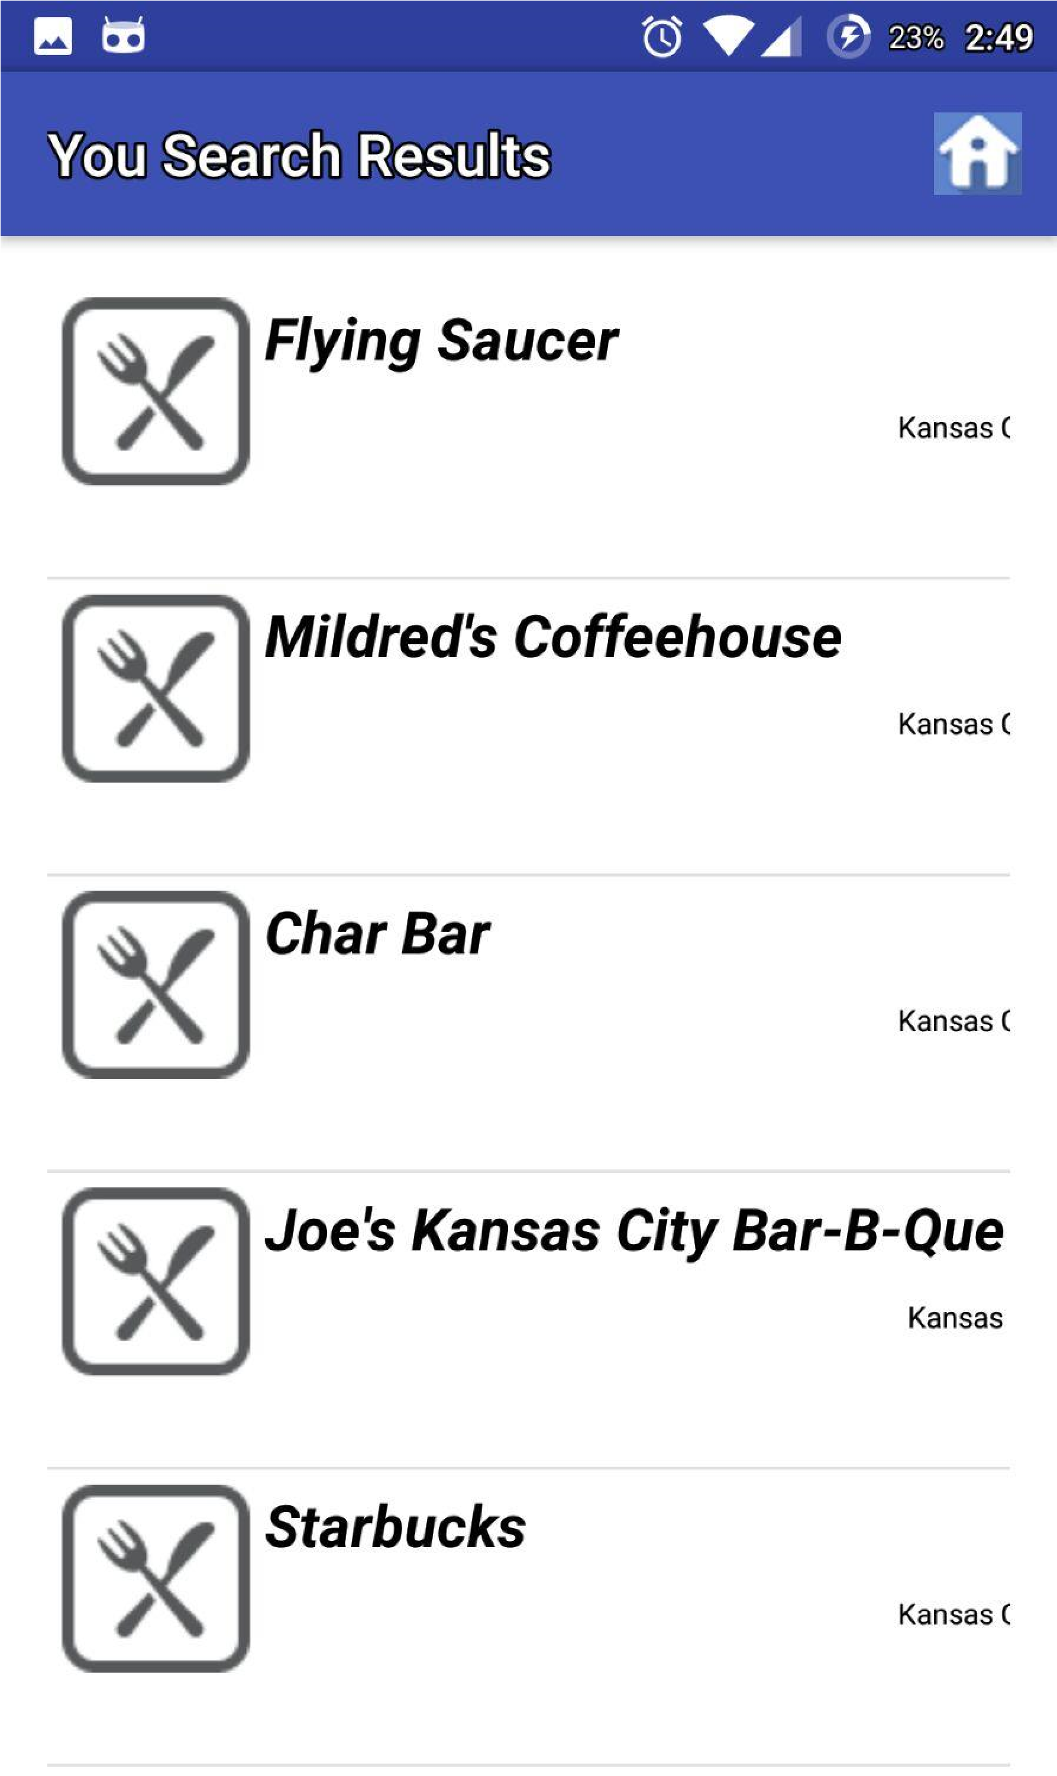

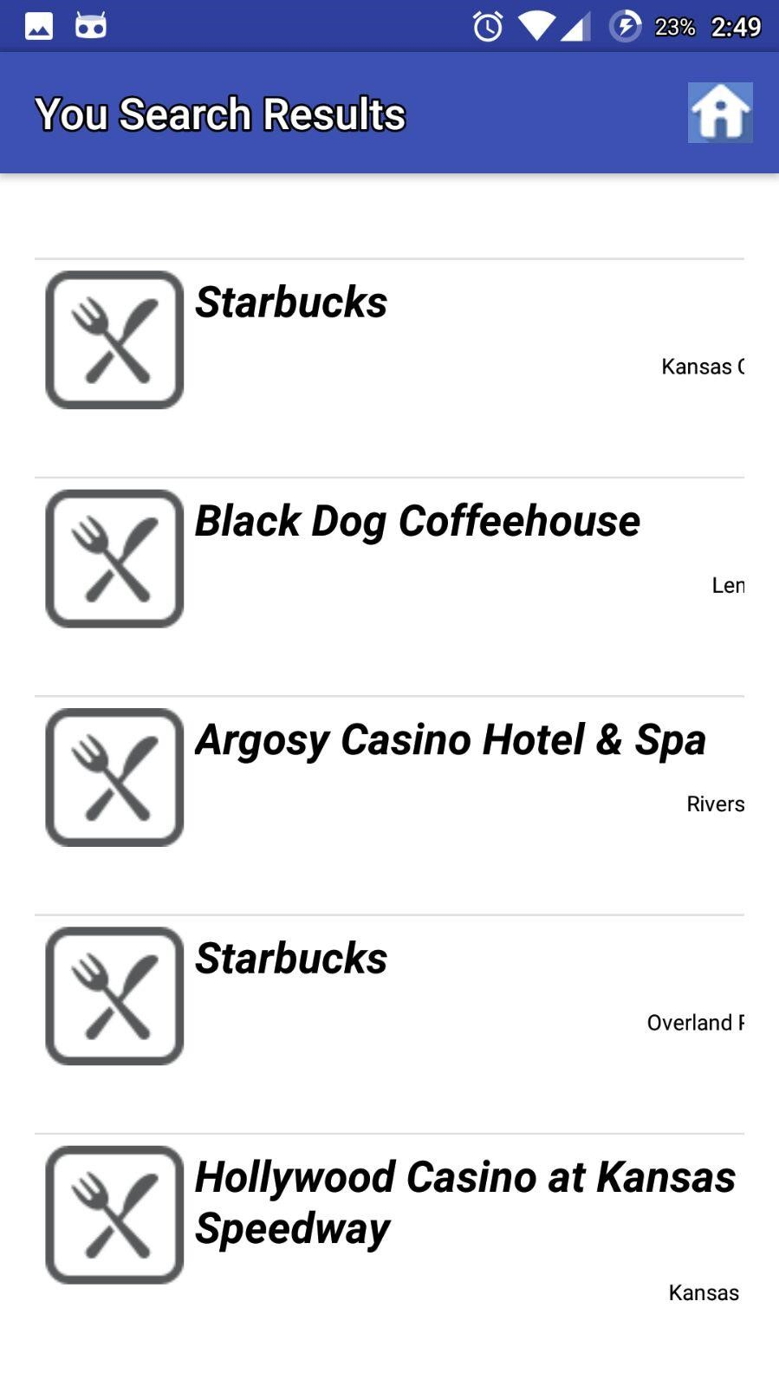

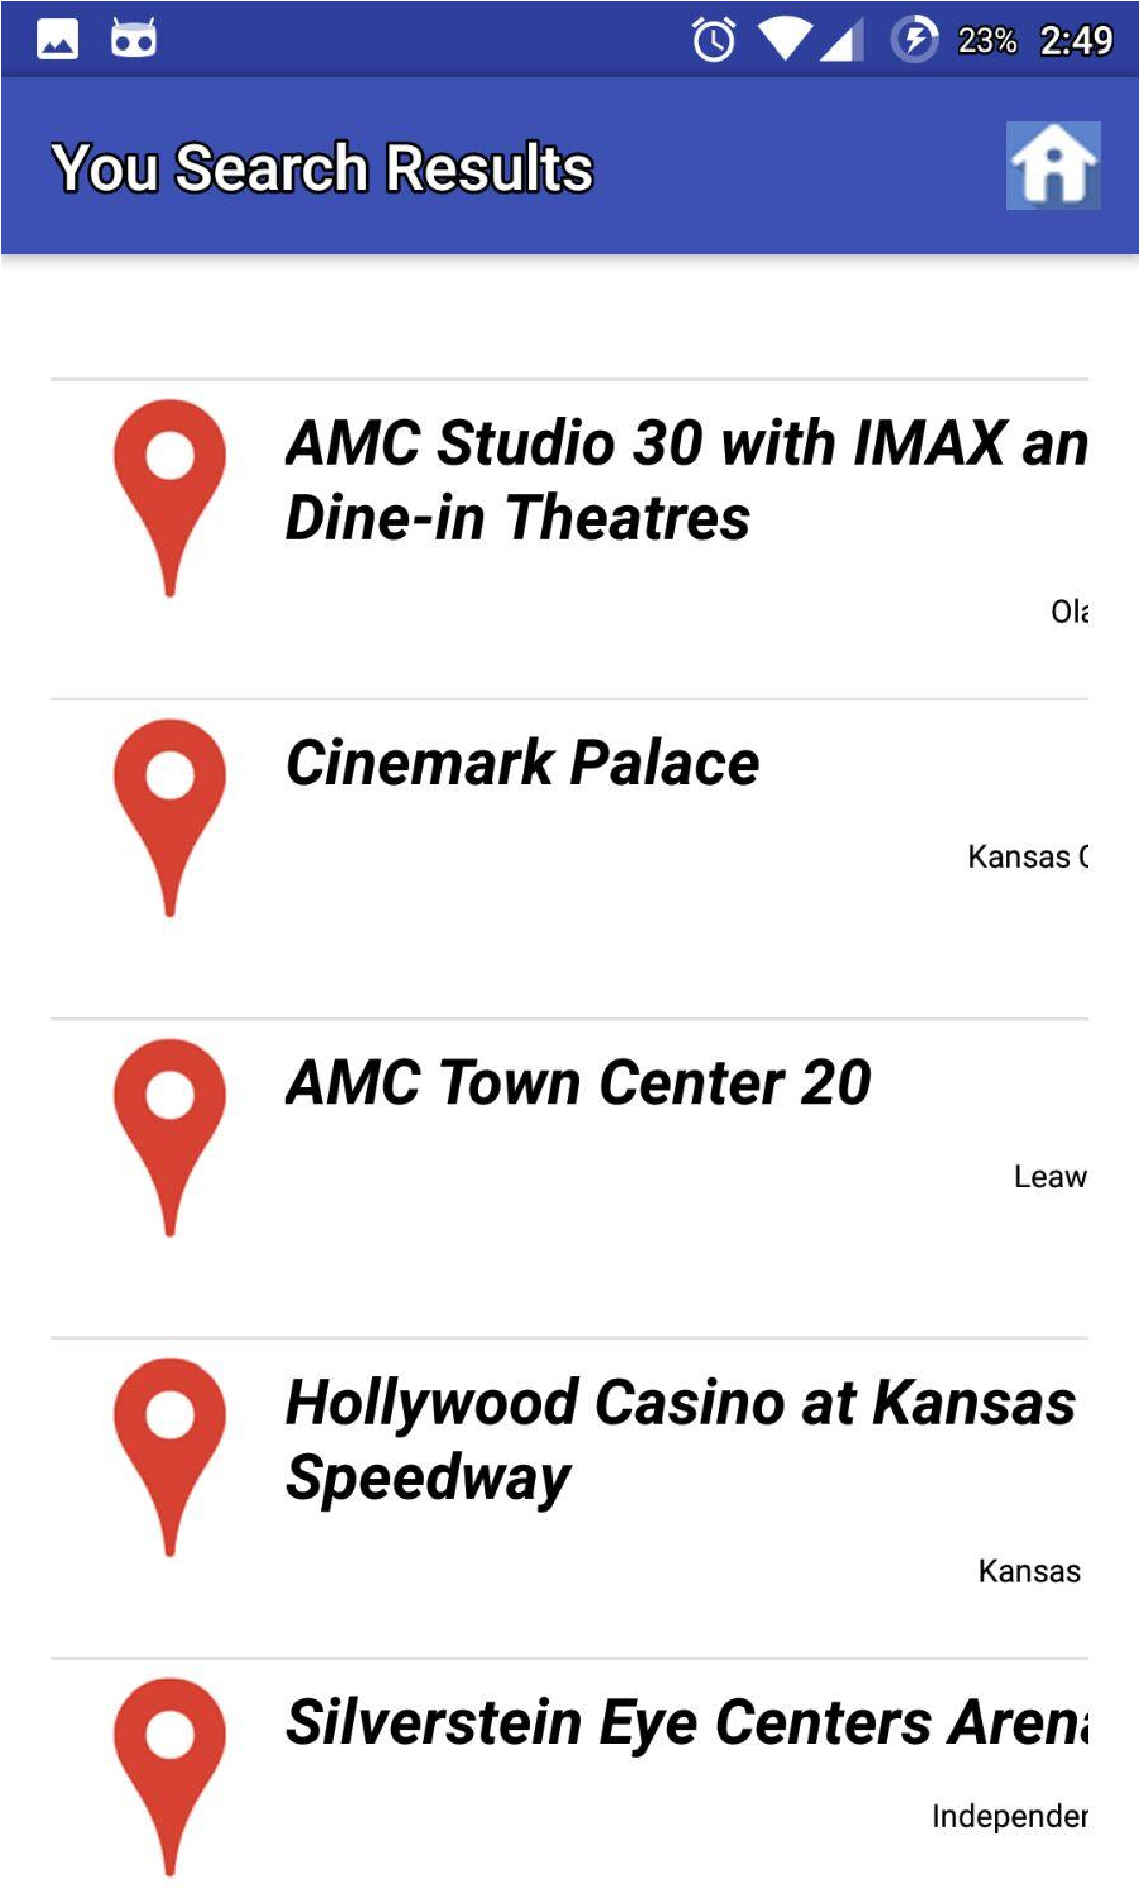

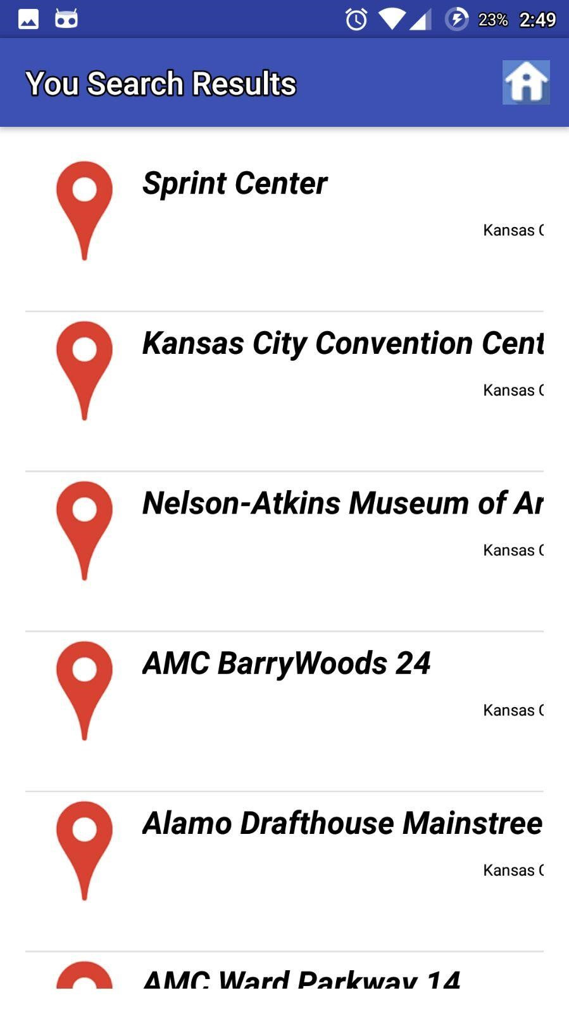

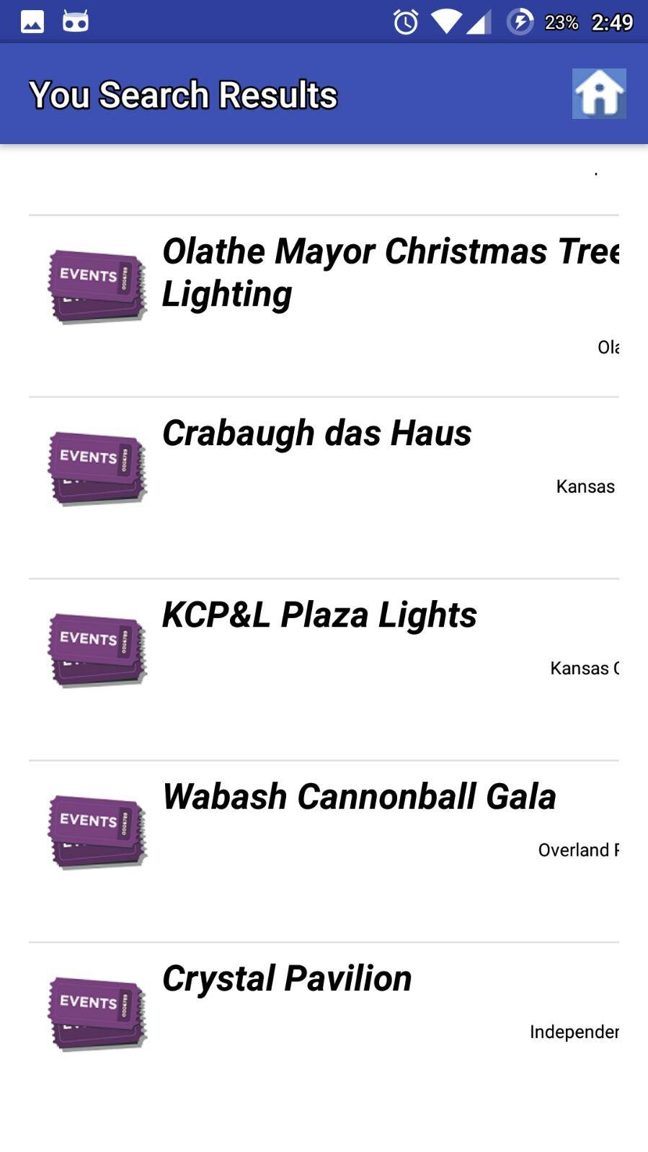

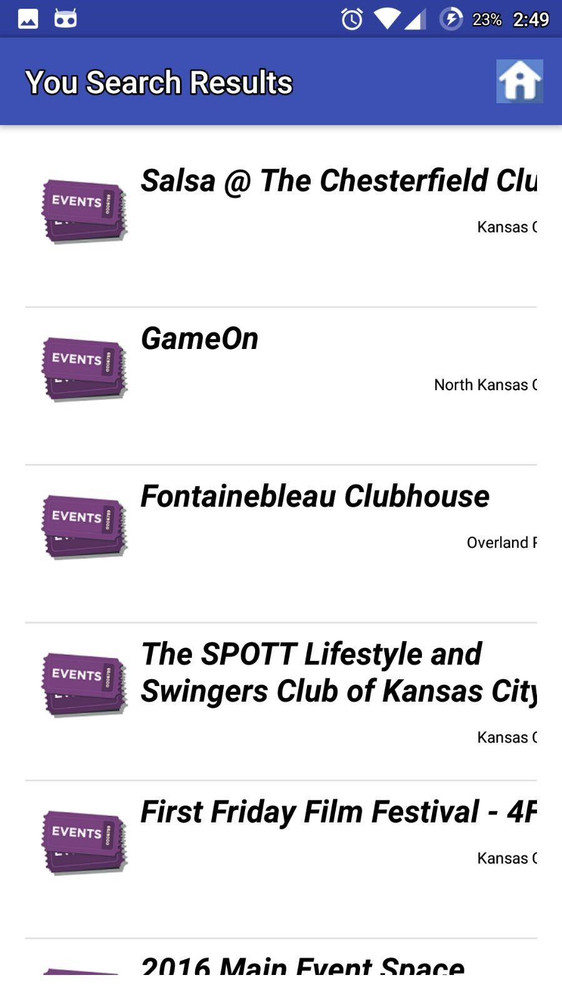

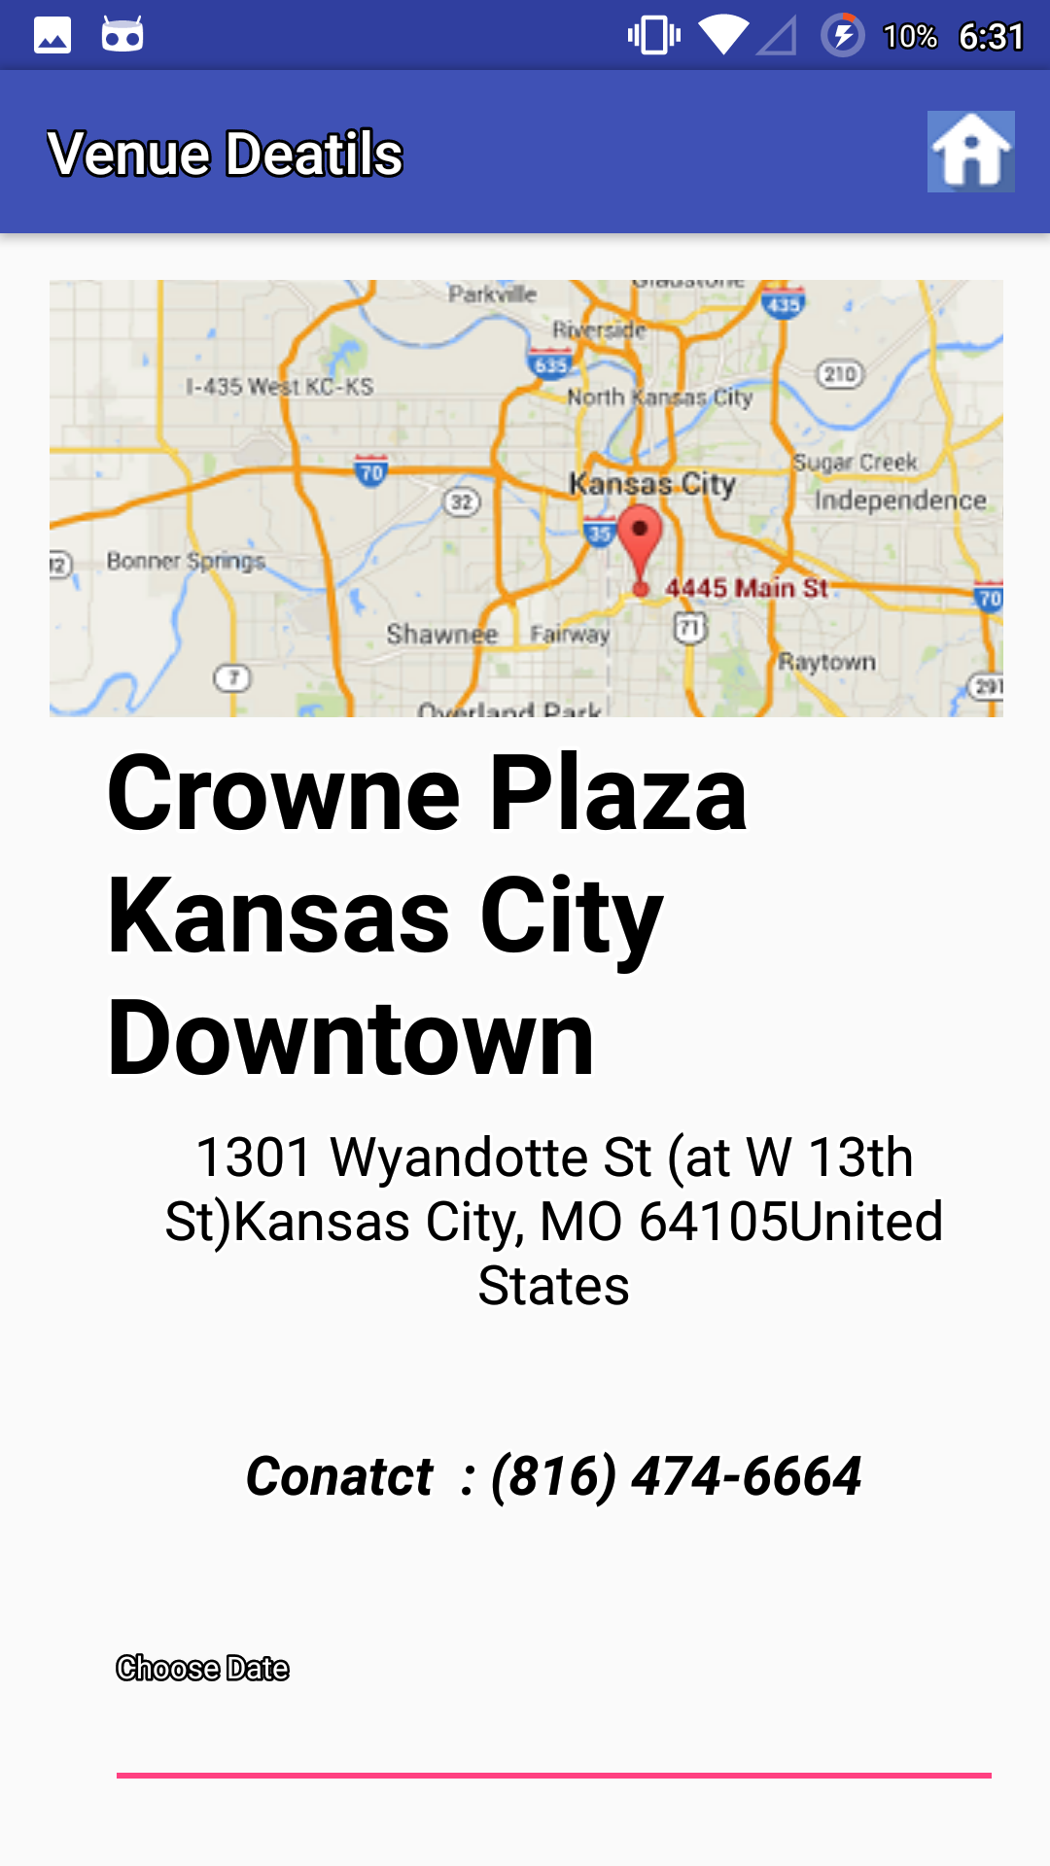

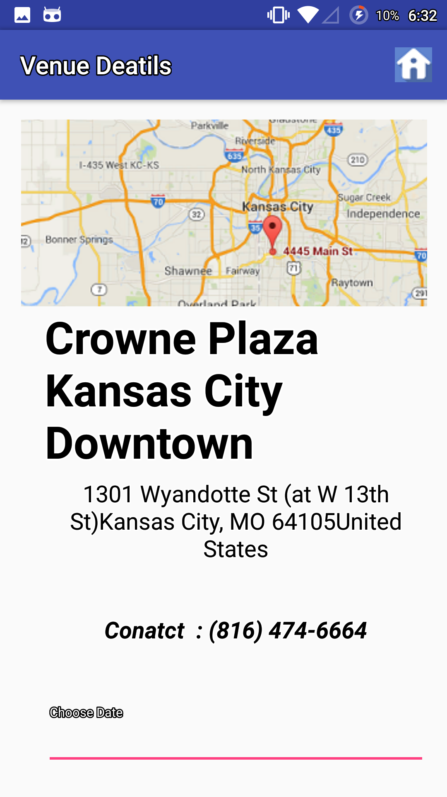

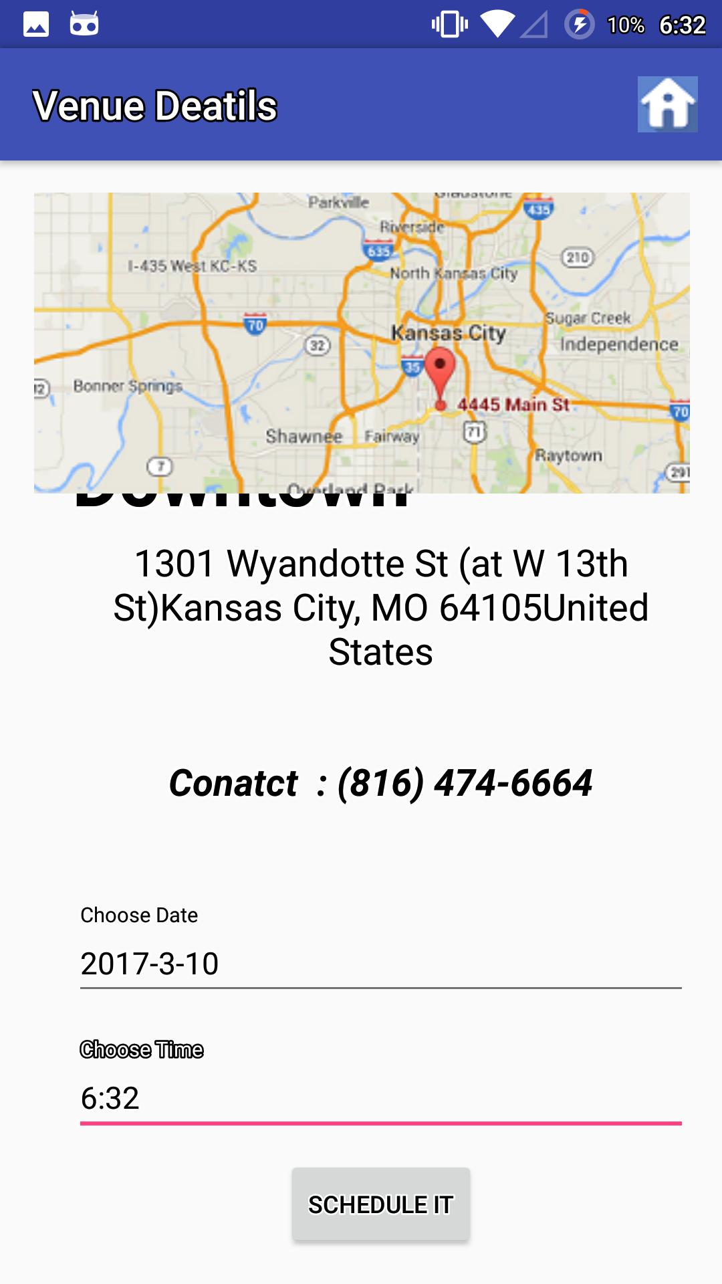

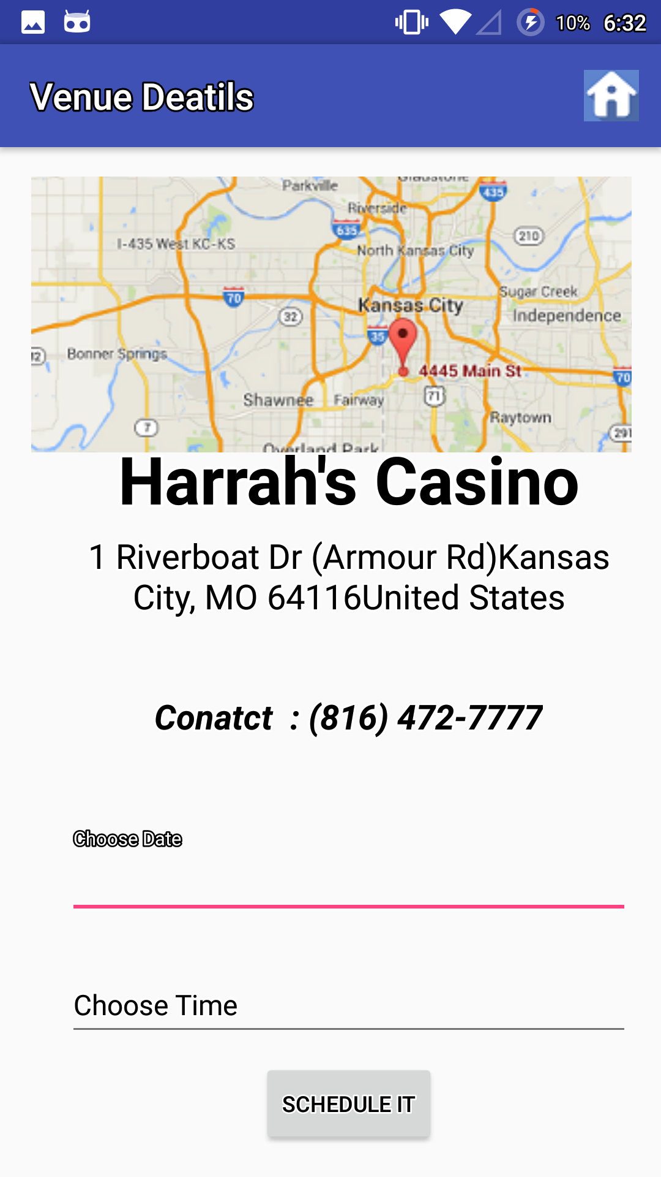

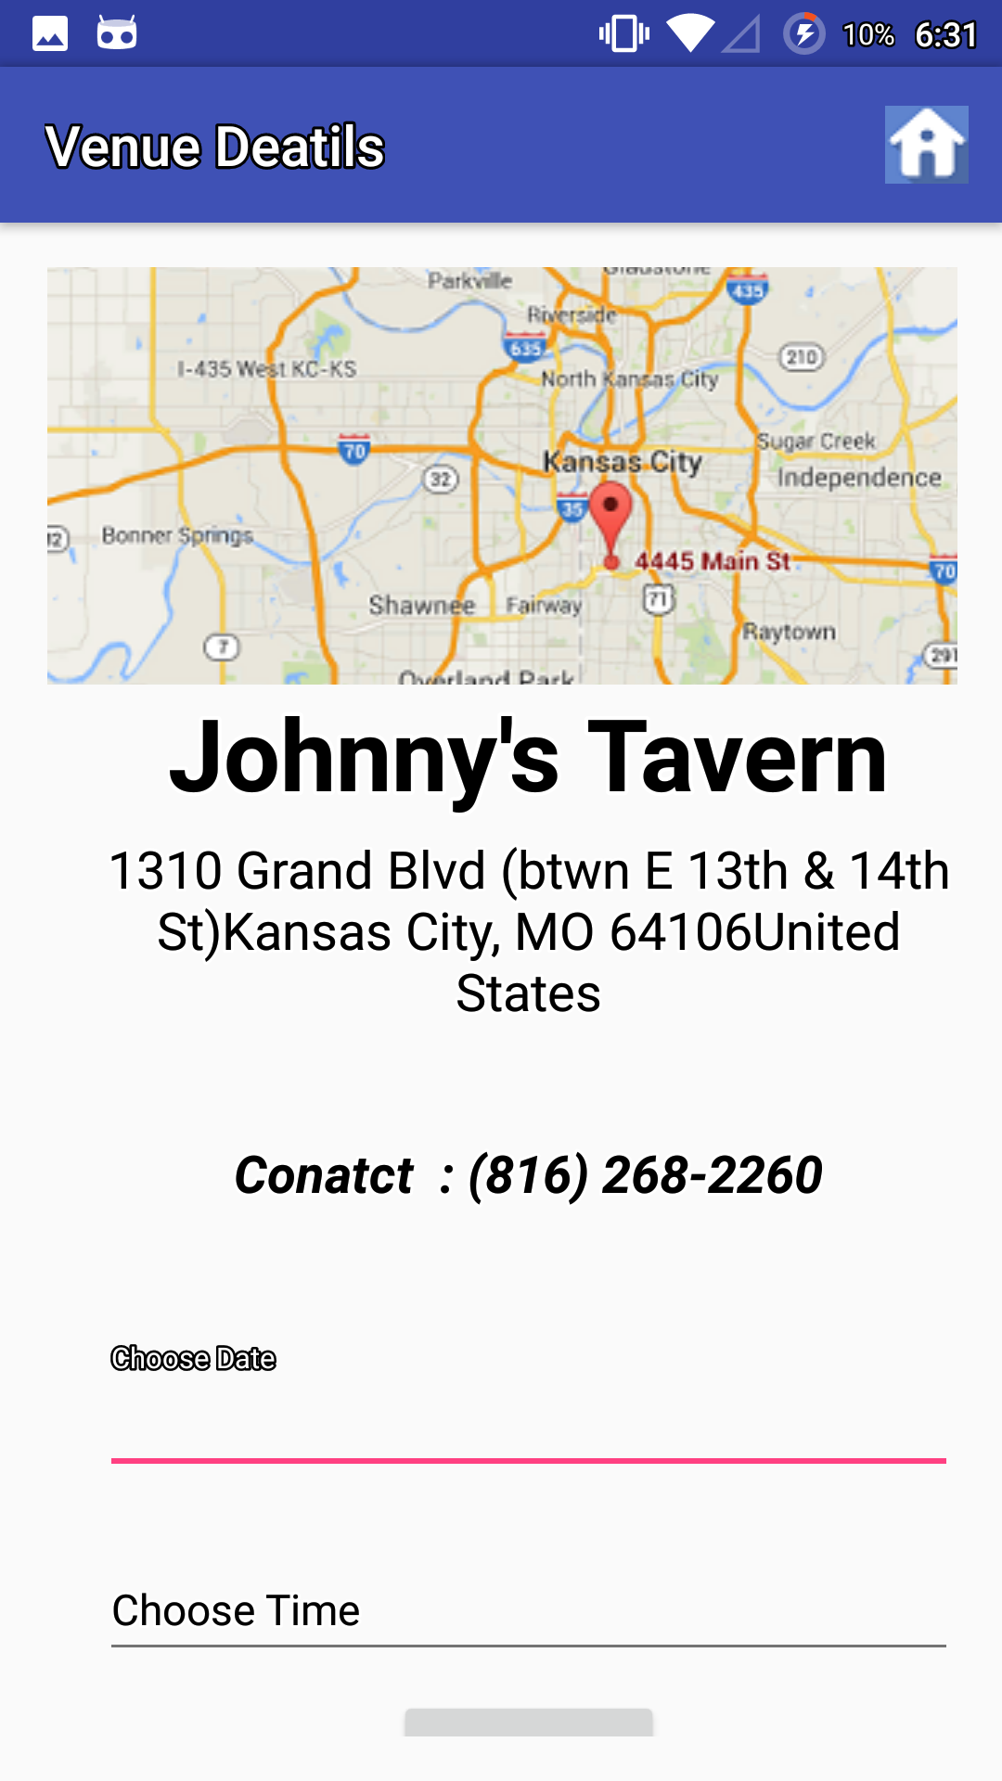

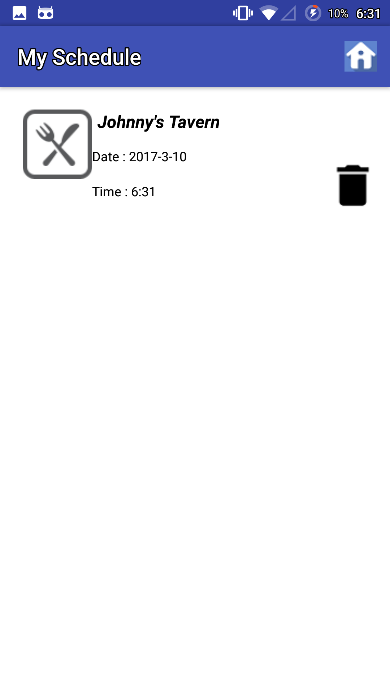

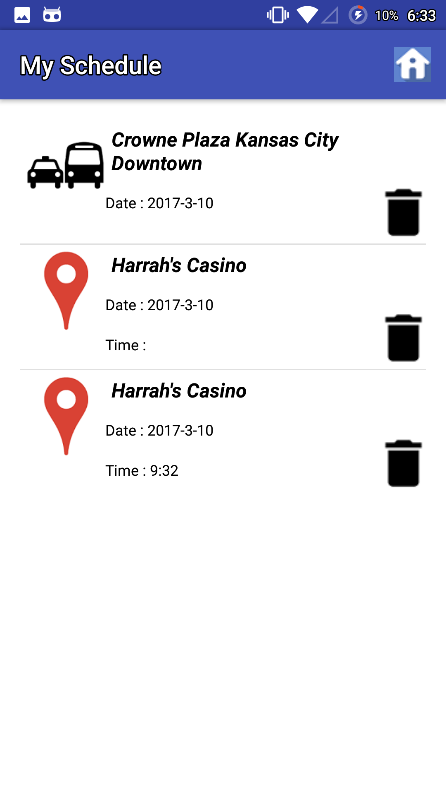

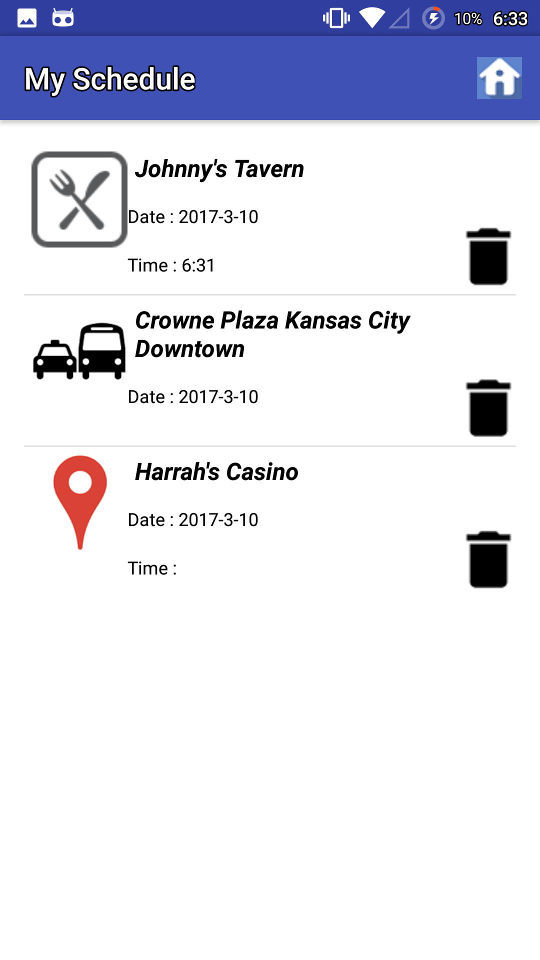

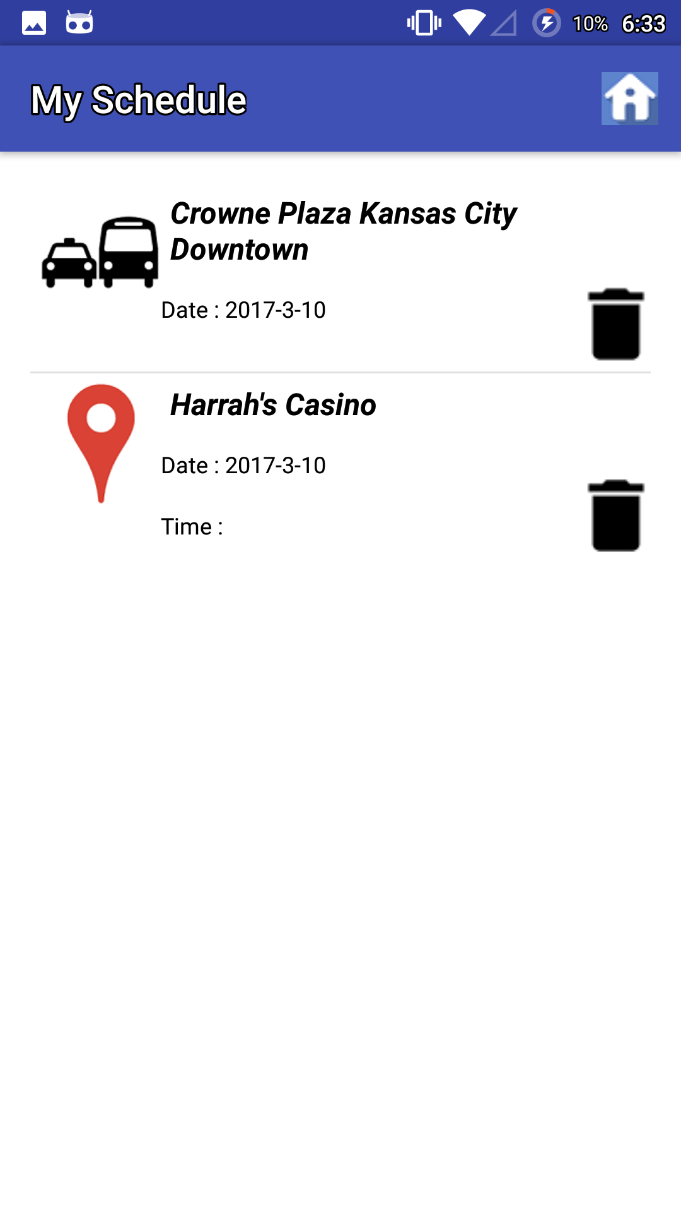

**“M-Lab Screenshots:”**

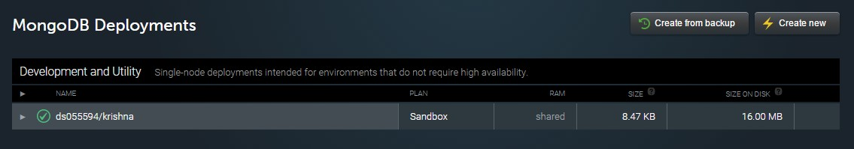

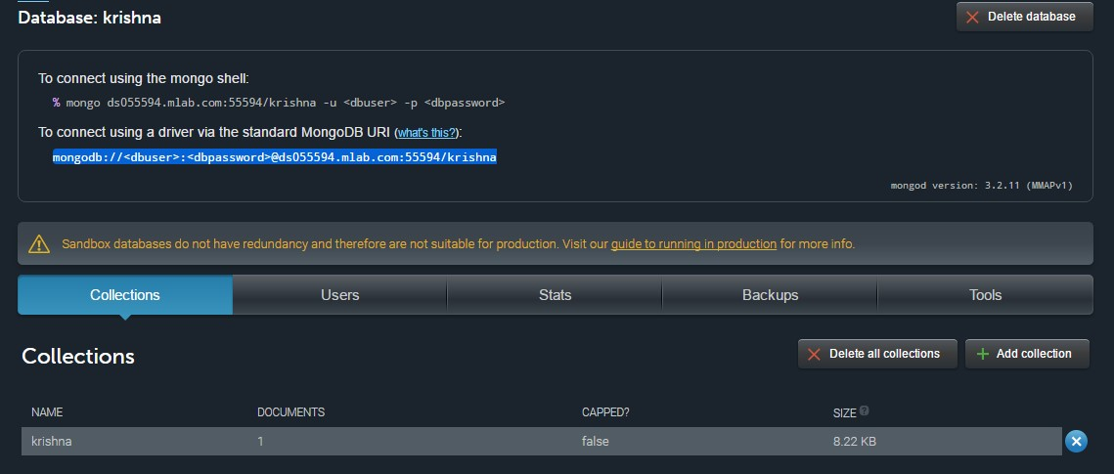

**“GitHub Wiki Link:”**

<https://github.com/OnicaRayineedi/ASE_Project/wiki/Project-Third-Increment>

**“6. Project Management”**

### “Implementation Status report:”

**“Technologies used:”** Android Studio, M-lab

**“Work Completed:”**

* Designed Architecture of the application
* Designed Login and registration pages
* Collected related information which will be used for further implementation of the Application
* Designing home page
* Database implementations

**“Work to be Completed:”**

* Implementing various API’s in the Application
* Implementing database to the Application
* Improving the UI of the Application

**“Contribution:”**

* 1. Onica Sai Prasanna Lakshmi, Rayineedi – 25%
  2. Venkata Krishna, Podili– 25%
  3. Mamatha Yadav, Chekuti– 25%
  4. Sreelekha Reddy Kommareddy-25%

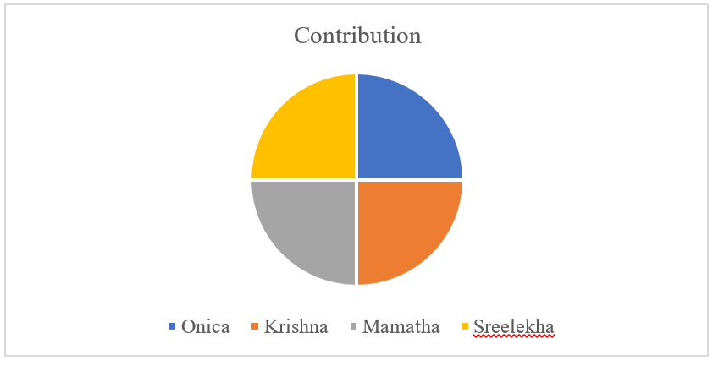

**“Bibliography:”**

* <https://creately.com/>
* [https://stackoverflow.com](https://stackoverflow.com/)